**Lab 6-Linux Jobs Controls**

**Tasks**

**1) Look at the man page of “ps” and search for “STANDARD FORMAT SPECIFIERS” run the following**

**command.**

**ps -o pid,ppid,cmd -u your_user_id**

**ps**



**ps -o pid**



**ps -o ppid**



**ps -o cmd -u user**

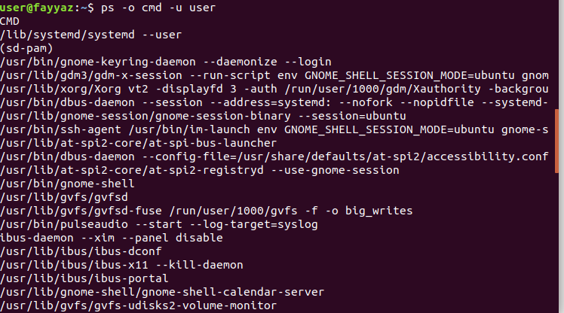

**2) What are the last three lines of output? now run the same command by adding the -H option.**

**ps -H -o pid,ppid,cmd -u your_user_id**

**ps -H -o pid**



**ps -H -o ppid**



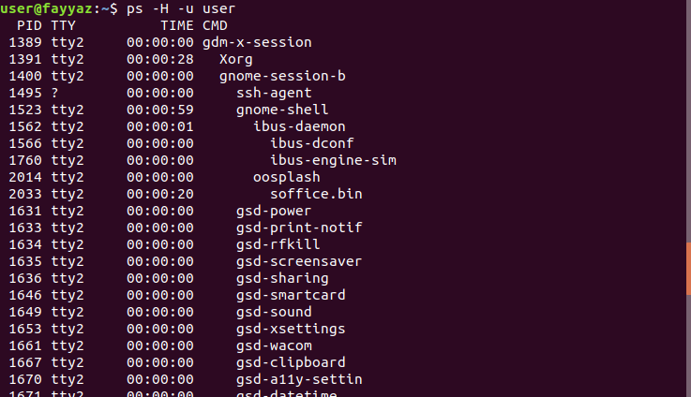**ps -H-u user**

**3) How would you use the tail command in a pipe to obtain the last six lines of output from the “ps -A command?**



**4) Which pipe of commands would you use to count the number of processes owned by you only?**

**Run the command and count how many processes you own?**

